CARD 5

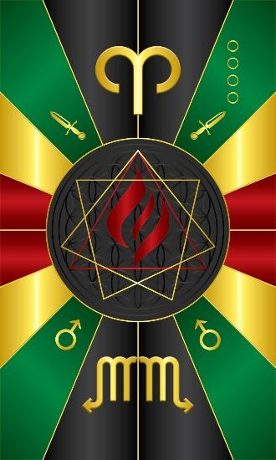
Card 5 represents the energy of Heru-Khuti/Ogun. The colors for Ogun are Green and Black, and Red. Those of Heru-Khuti, blood red. The sacred numbers for Ogun are a combination of 3, and 7. Here, we have both the triangle and a 7 sided star in combination. The pyramid stands for fire in the middle, and we see a flame in the middle of the pyramid. Above is the symbol for the constellation Aries and below is the symbol for the constellation of Scorpio. At the angles below we have the astrological symbol for Mars and a set of sharp knives to which they correspond. Machete’s, knives, etc., for clearing the way, removing obstacles.

Comments by Baba Awodele

